Project Design Phase-II
Data Flow Diagram & User Stories

Date | 7 October 2026
Team ID
Project Name | Script-Controlled ACL – Restrict Record Access Based on Field Value
Maximum Marks | 4 Marks

Data Flow Diagrams:
A Data Flow Diagram (DFD) is a traditional visual representation of the information flows within a system. A neat and clear DFD can depict the right amount of the system requirement graphically. It shows how data enters and leaves the system, what changes the information, and where data is stored.
Example: Script-Controlled ACL – Restrict Record Access Based on Field Value – https://www.servicenow.com/docs/r/yokohama/platform-security/access-control/exploring-access-control-list.html?contentId=oczJQGZK~1lGzH~ITrwZHg
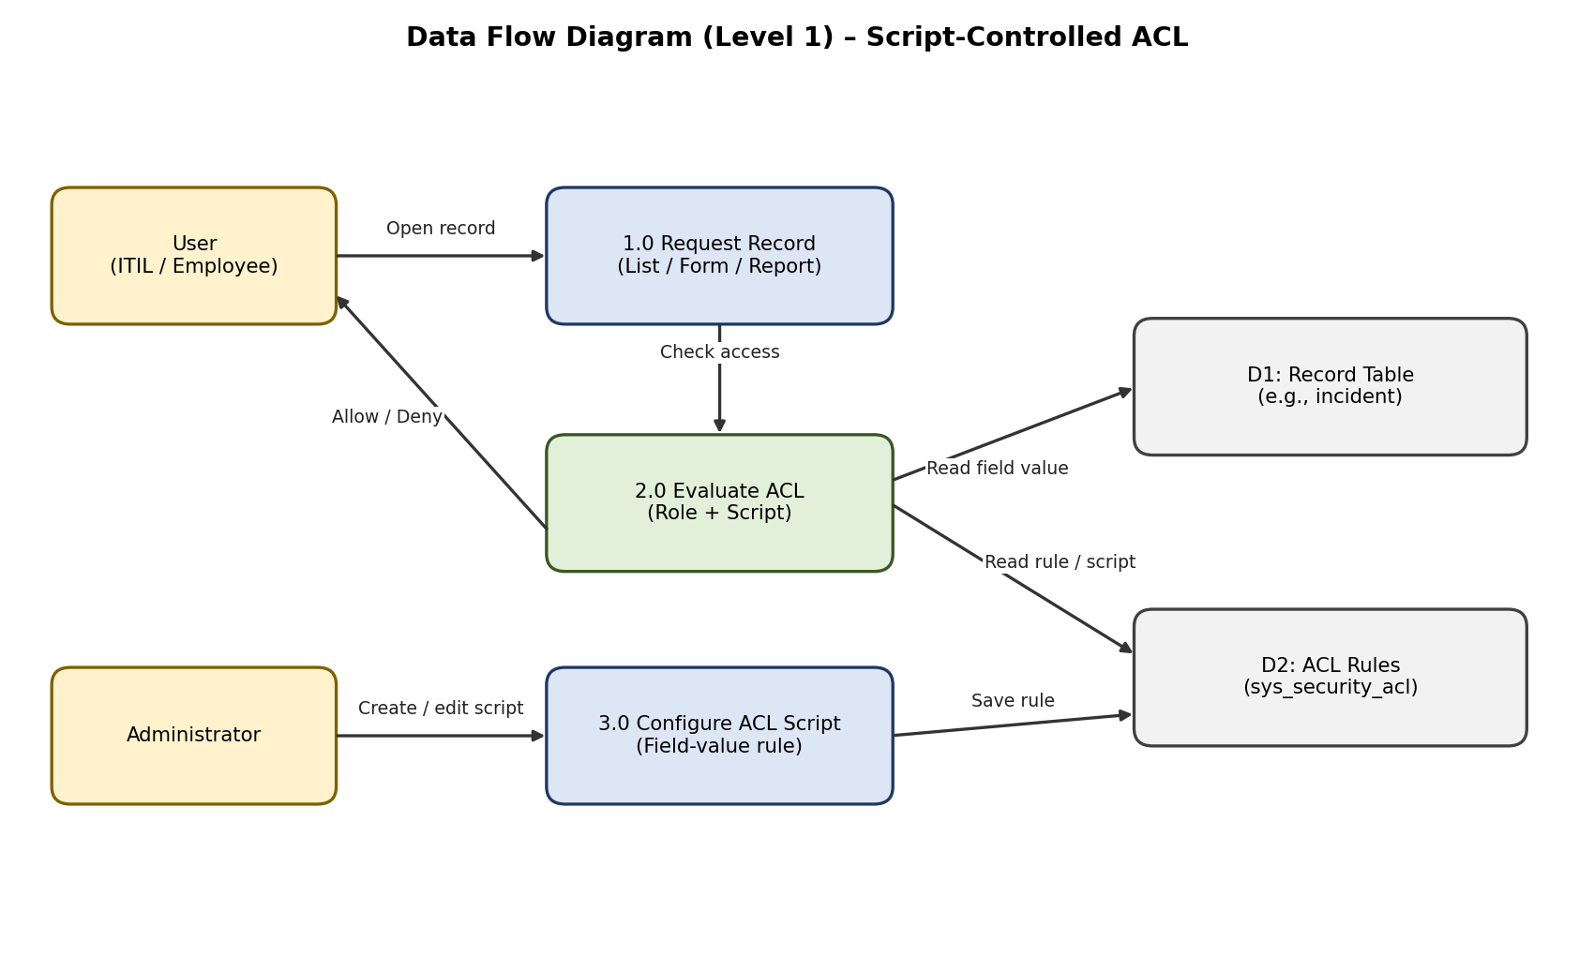
User Stories
Use the below template to list all the user stories for the product.
User Type | Functional Requirement (Epic) | User Story Number | User Story / Task | Acceptance criteria | Priority | Release
Administrator | Script-Controlled ACL | USN-1 | As an administrator, I can create a record-level ACL with a script for the table. | ACL is saved and active | High | Sprint-1
 |  | USN-2 | As an administrator, I can check the field value (e.g., Sensitivity) inside the ACL script. | Script returns true / false based on the field value | High | Sprint-1
 | Reusable Access Logic | USN-3 | As an administrator, I can move the access logic into a Script Include for reuse. | ACL calls the Script Include successfully | Medium | Sprint-2
Authorised User (Assigned user / Caller) | Field-Value Based Record Restriction | USN-4 | As an authorised user, I can open a Confidential record assigned to me. | I can view and edit the record | High | Sprint-1
 | Operation Coverage | USN-5 | As an authorised user, I can see the allowed records in the list view and reports. | Allowed records appear in lists and reports | Medium | Sprint-2
Unauthorised User | Field-Value Based Record Restriction | USN-6 | As an unauthorised user, I cannot open or see a Confidential record. | Record is hidden / access is denied | High | Sprint-1
Security / Compliance Officer | Administration & Testing | USN-7 | As a security officer, I can test the ACL by impersonating different users. | Results match the expected access for each user | High | Sprint-2
 | Administration & Testing | USN-8 | As a security officer, I can review the ACL script to confirm the rule for audits. | Script is documented and readable | Low | Sprint-3

